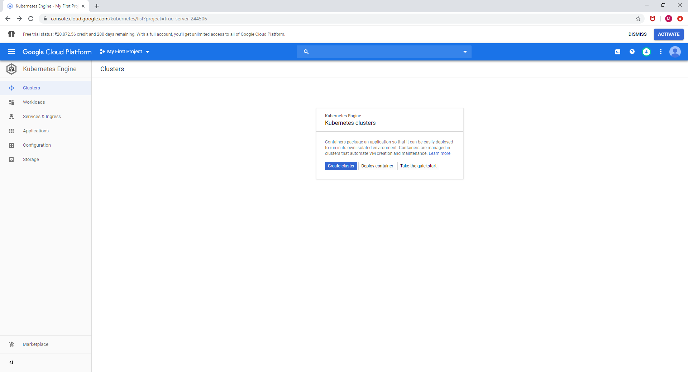

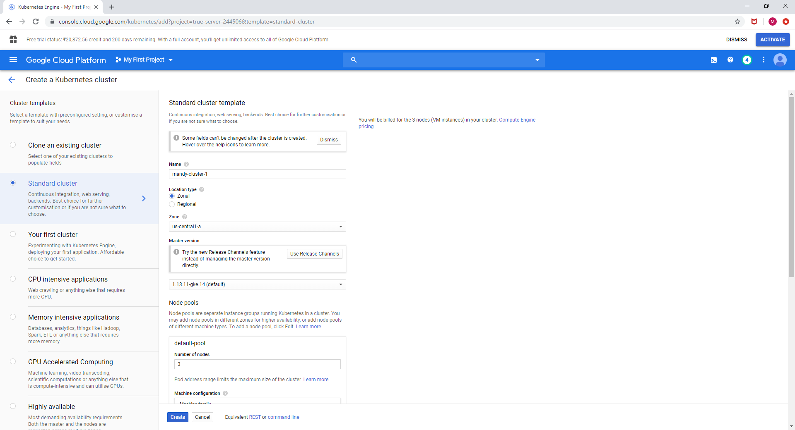



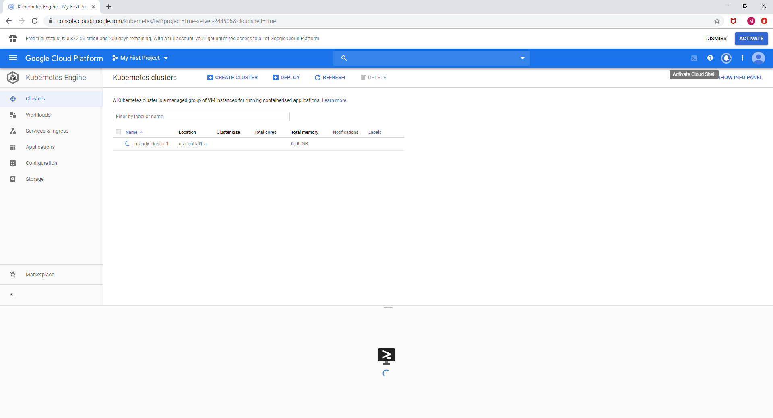

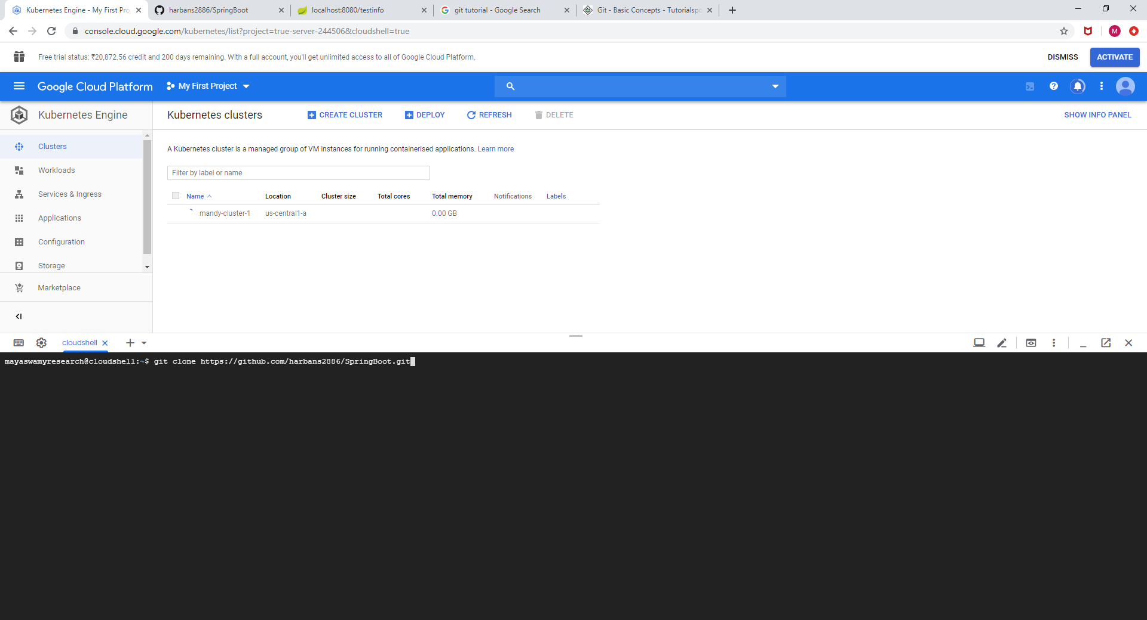

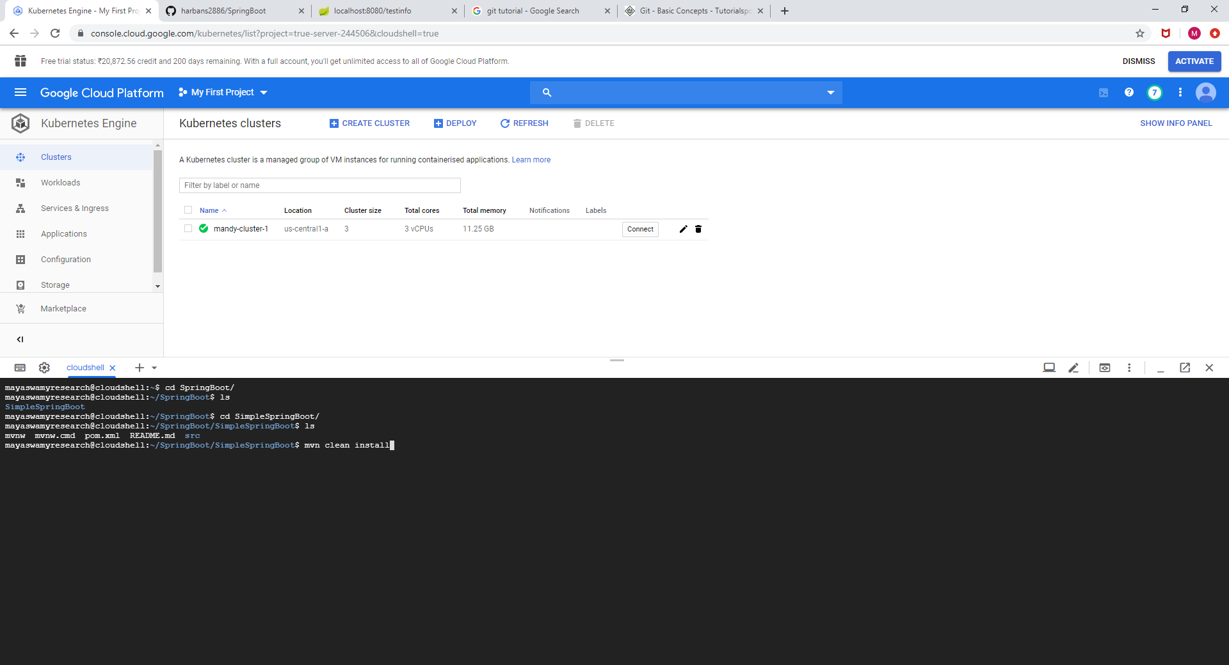

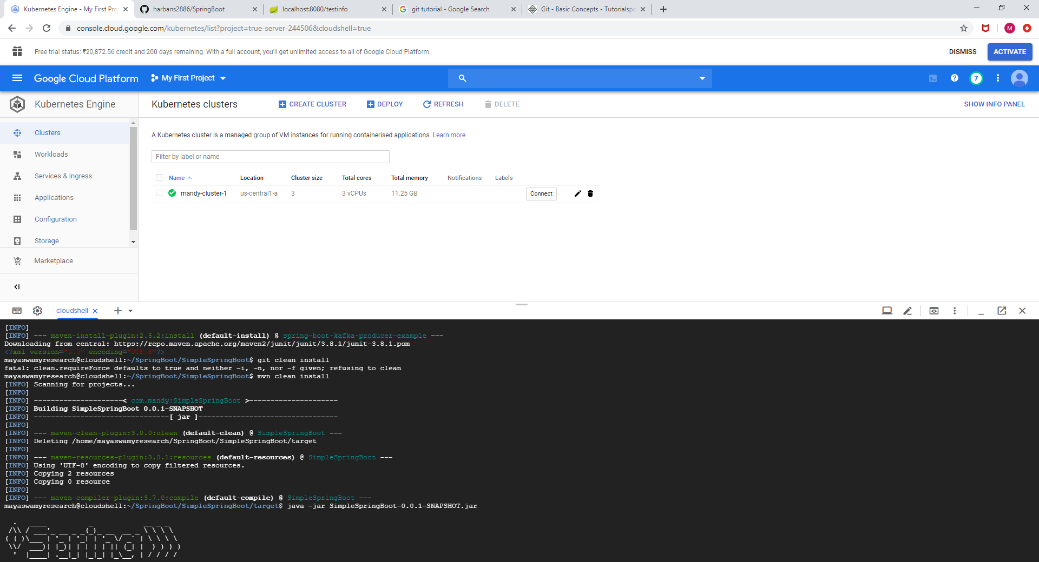

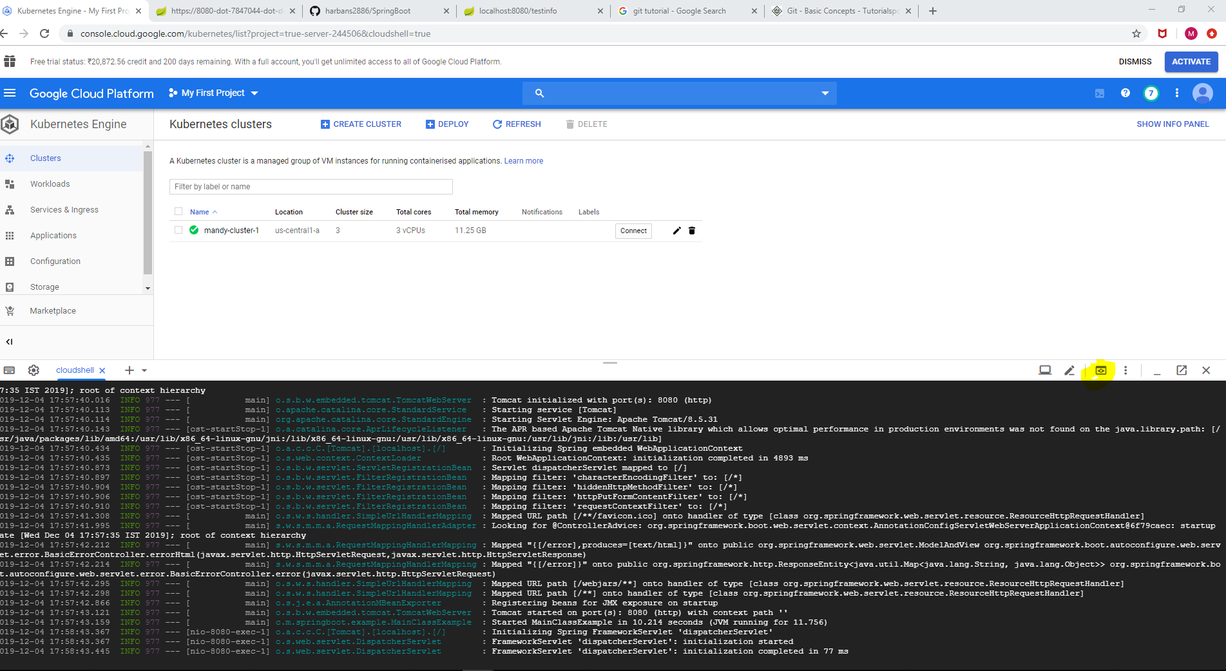

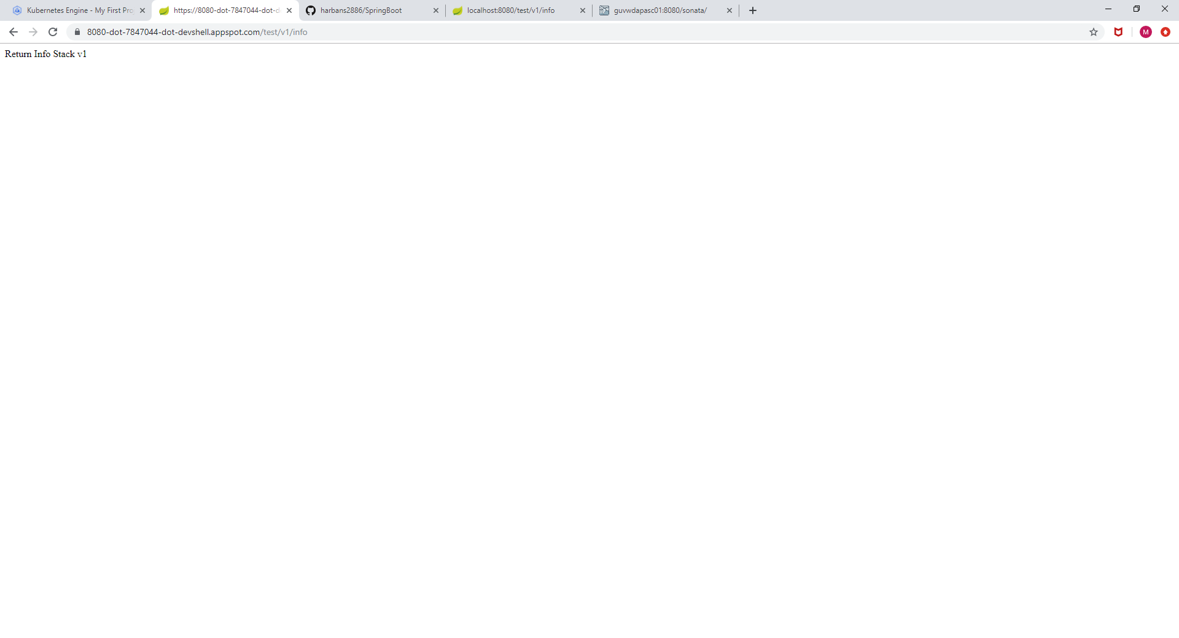

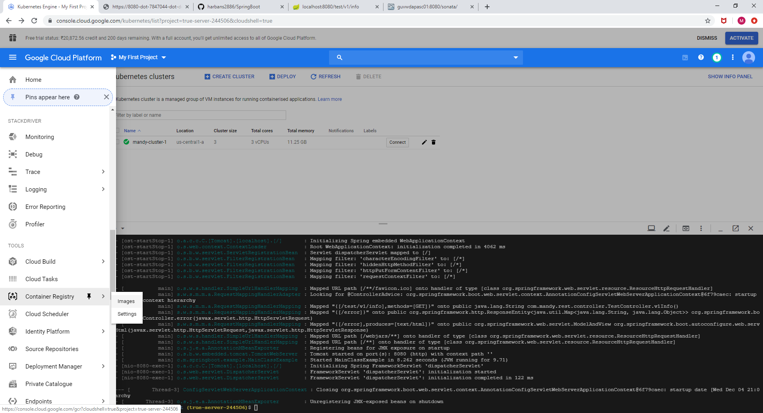

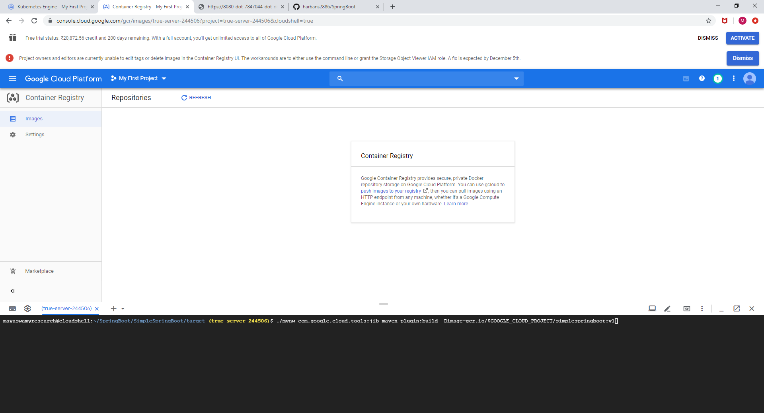

Create a docker image using mvnw(maven wrapper)

**./mvnw com.google.cloud.tools:jib-maven-plugin:build -Dimage=gcr.io/$GOOGLE_CLOUD_PROJECT/simplespringboot:v1** 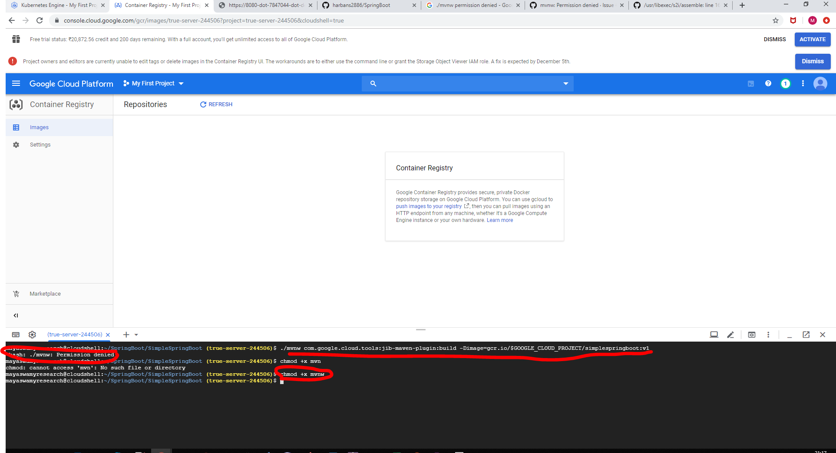

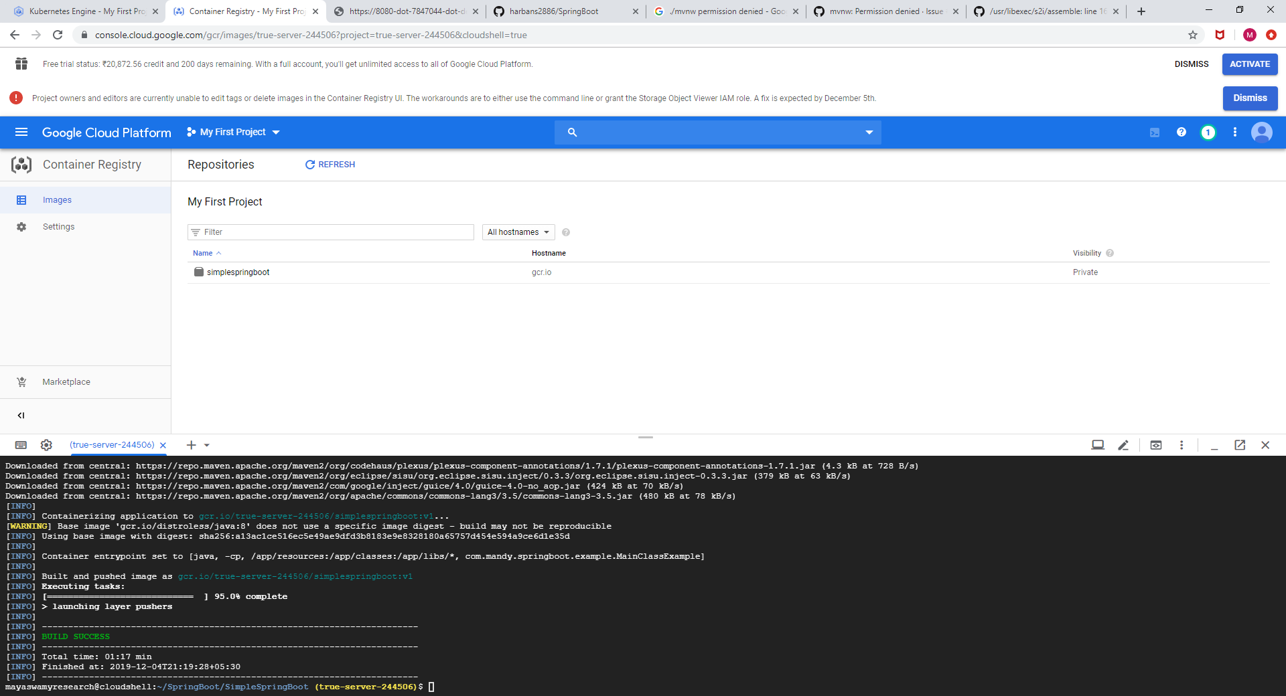

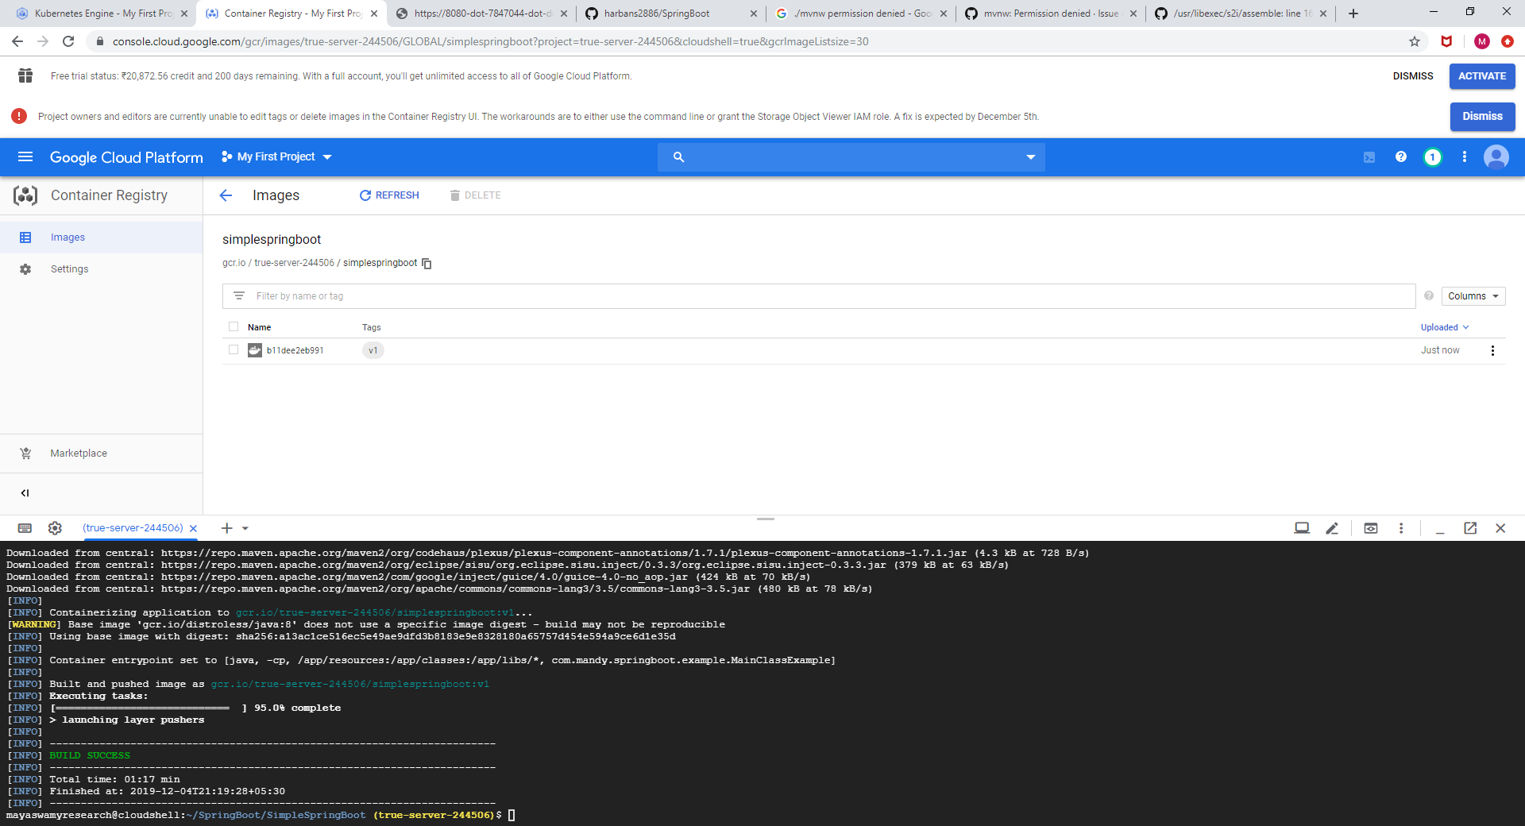

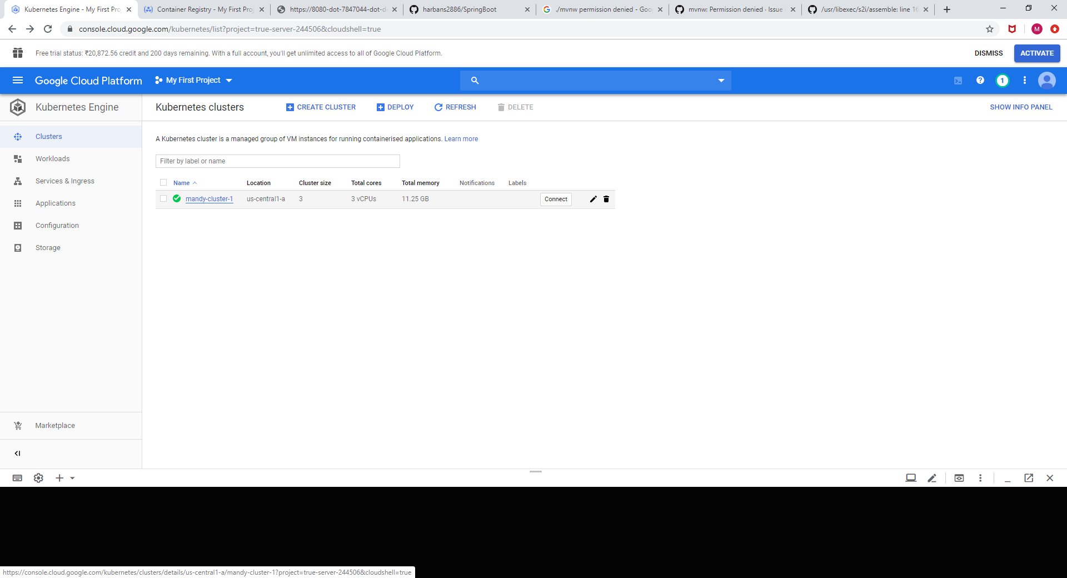

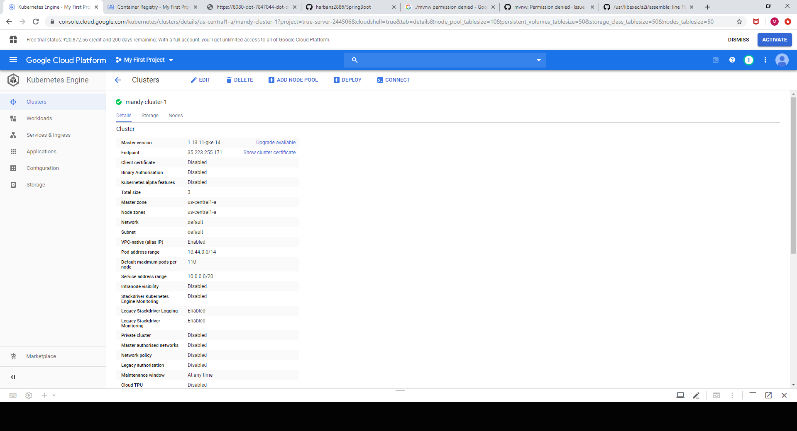

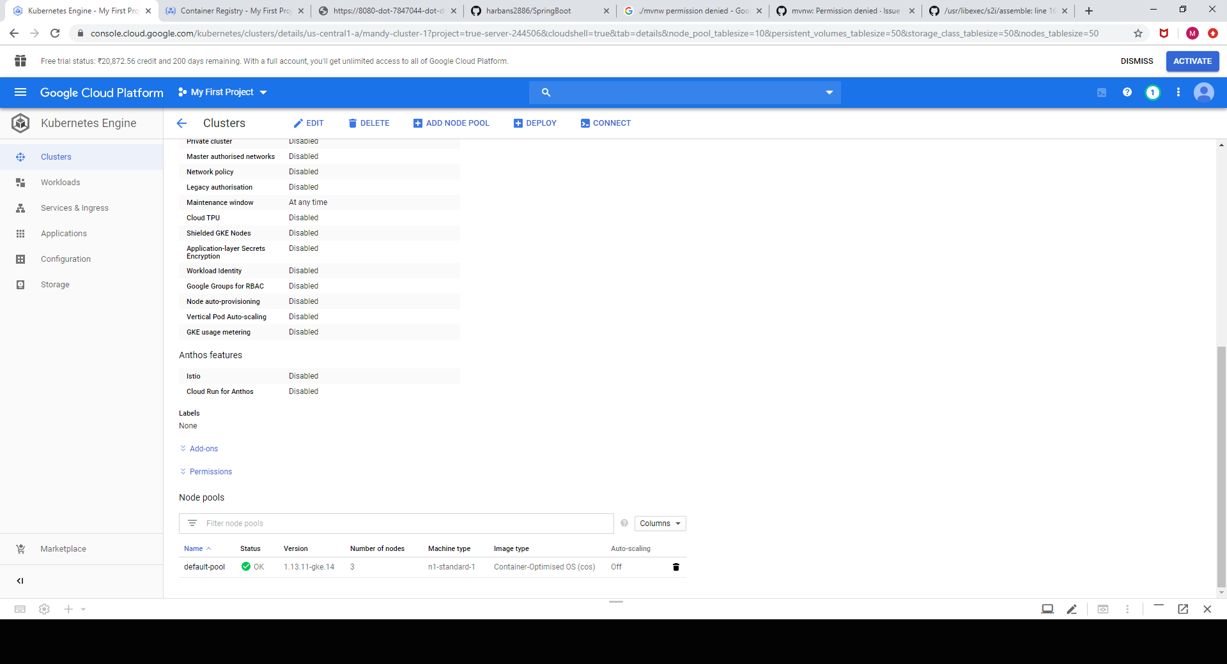

Login into the cluster

gcloud container clusters get-credentials mandy-cluster-1 --zone us-central1-a

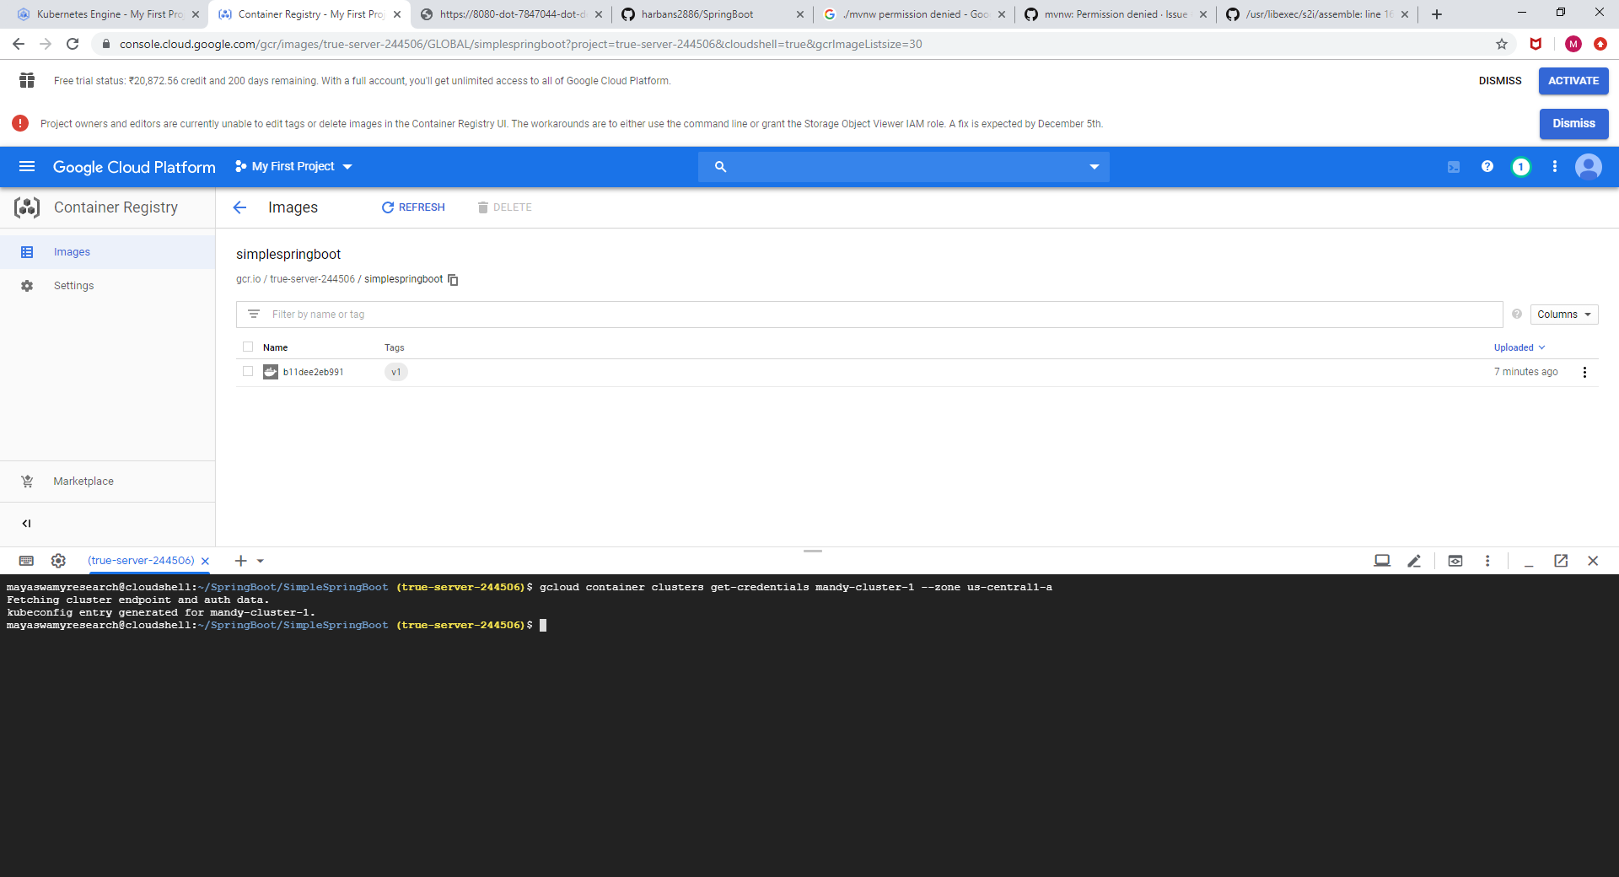

What are the PODS running in the cluster

**kubectl get pods**

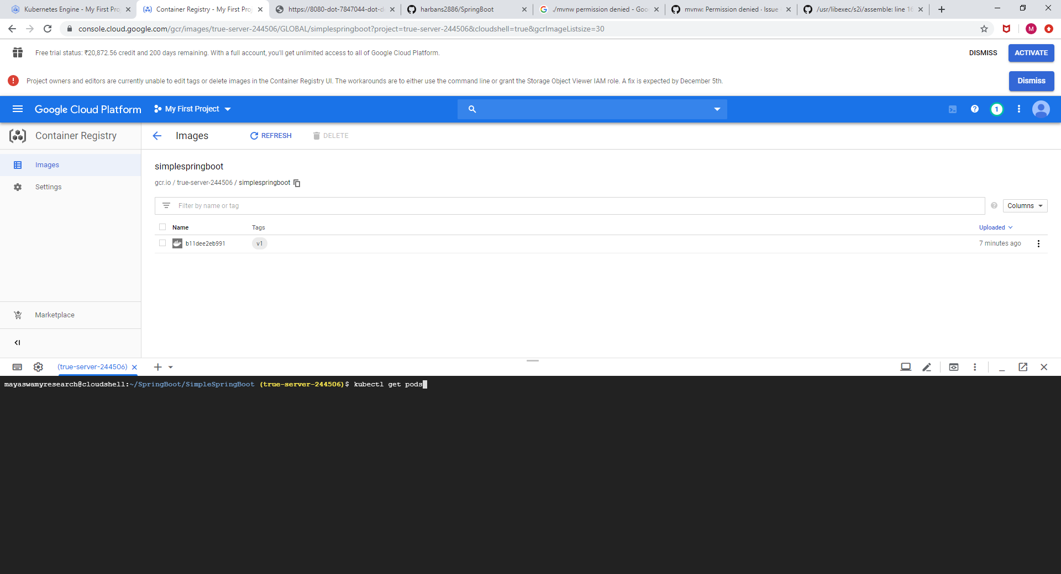

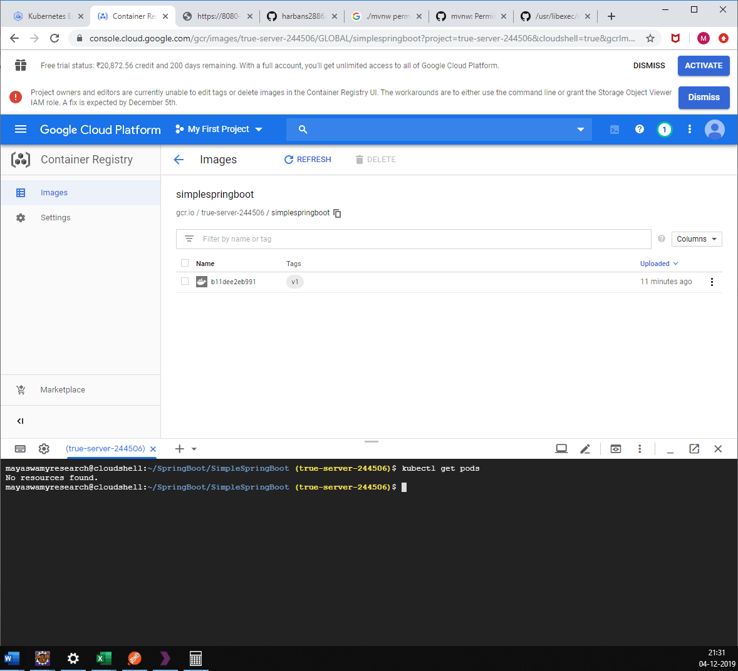

What are the Services running in the cluster

**kubectl get services**

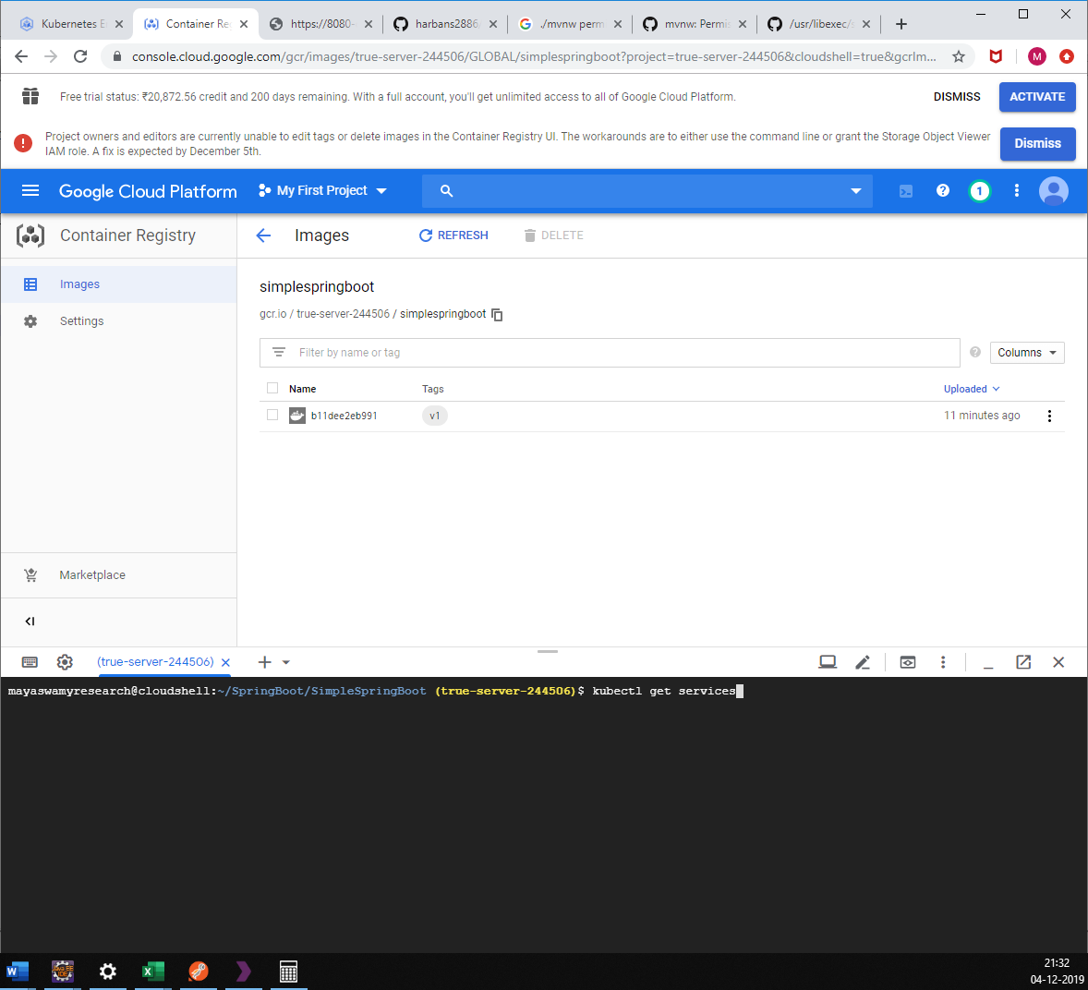

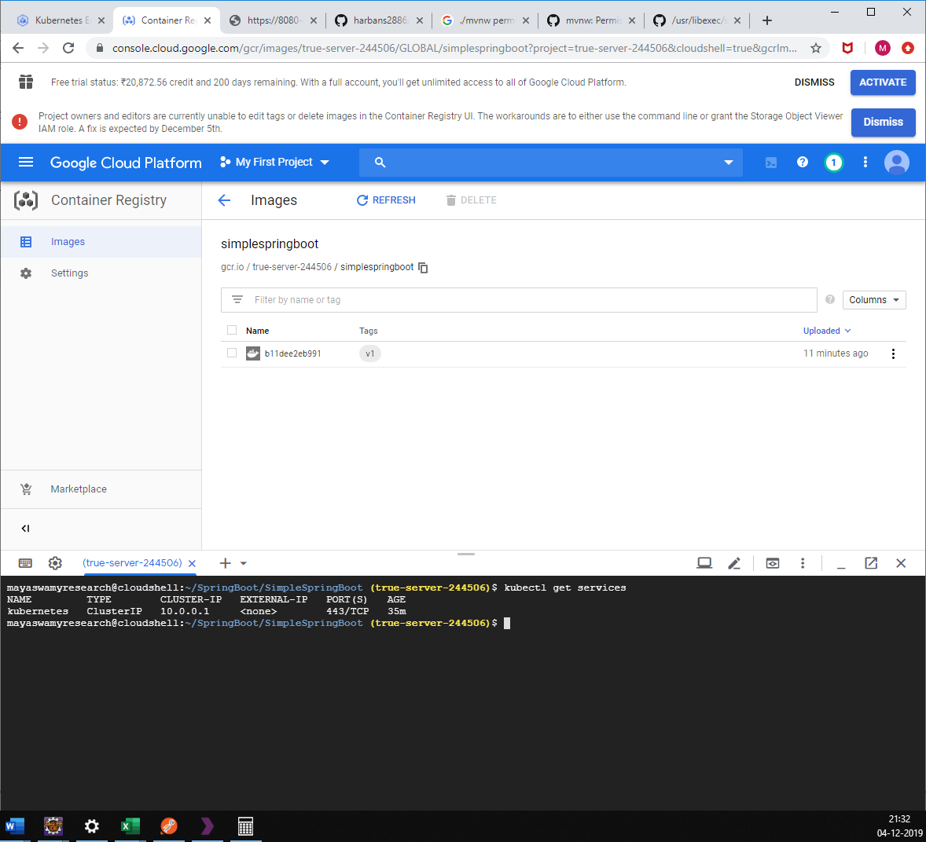

What are the Deployments running in the cluster

**kubectl get deployment**

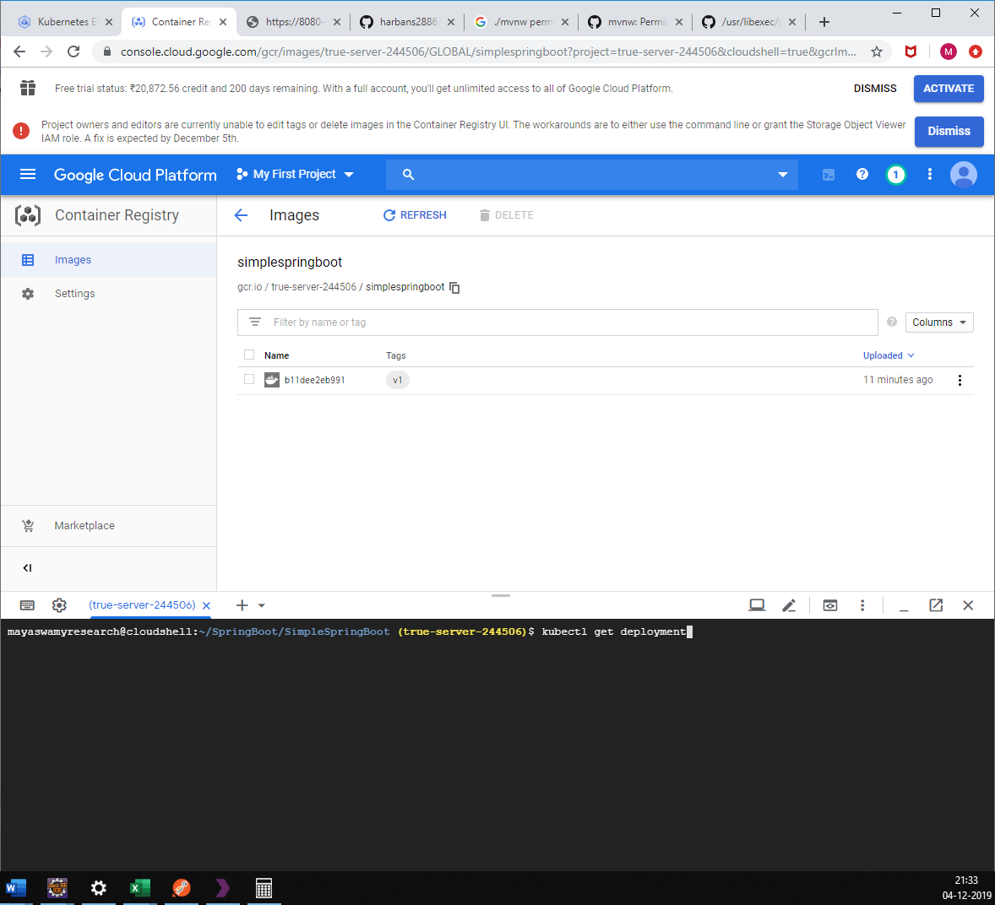

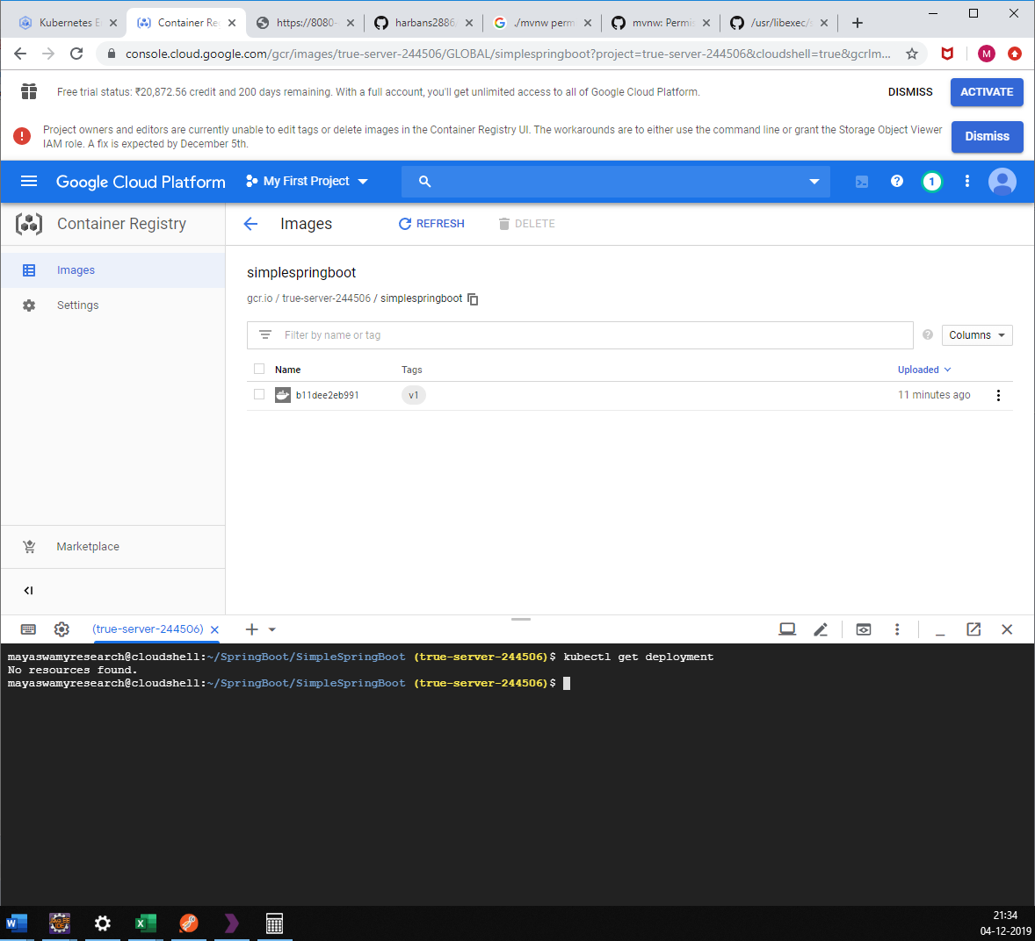

Check is Docker container out of newly created docker image is working fine or not.

docker run -ti --rm -p 8080:8080 gcr.io/$GOOGLE_CLOUD_PROJECT/simplespringboot:v1

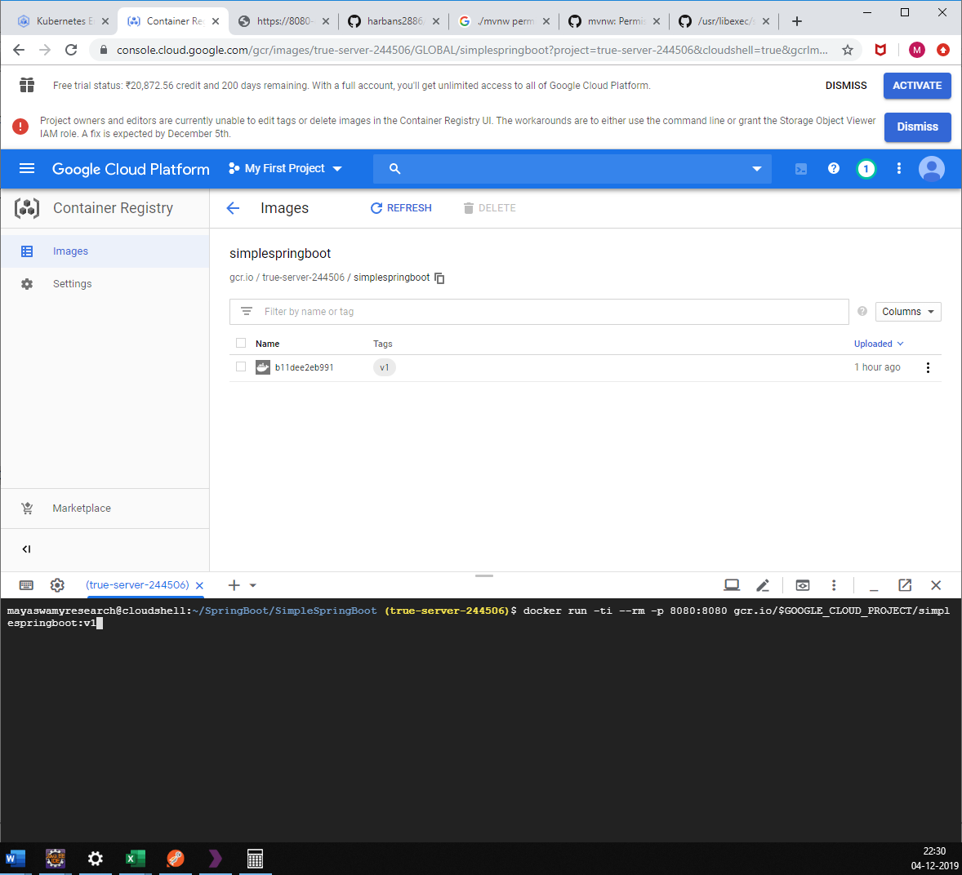

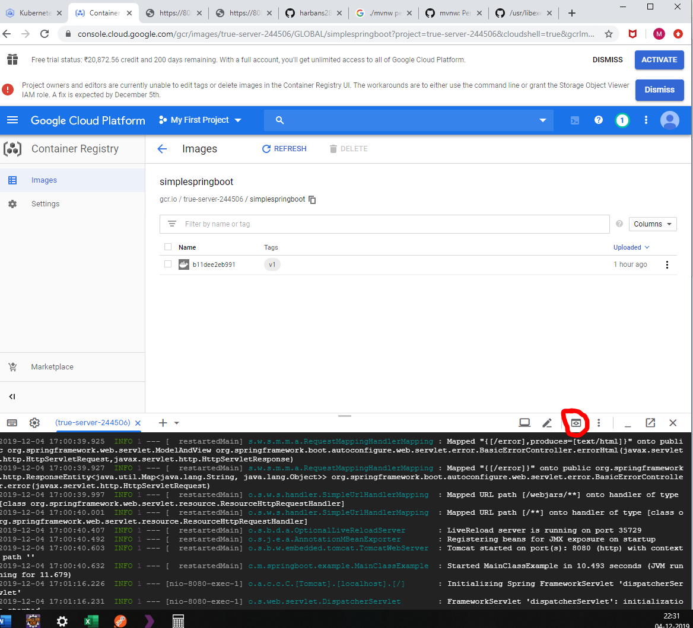

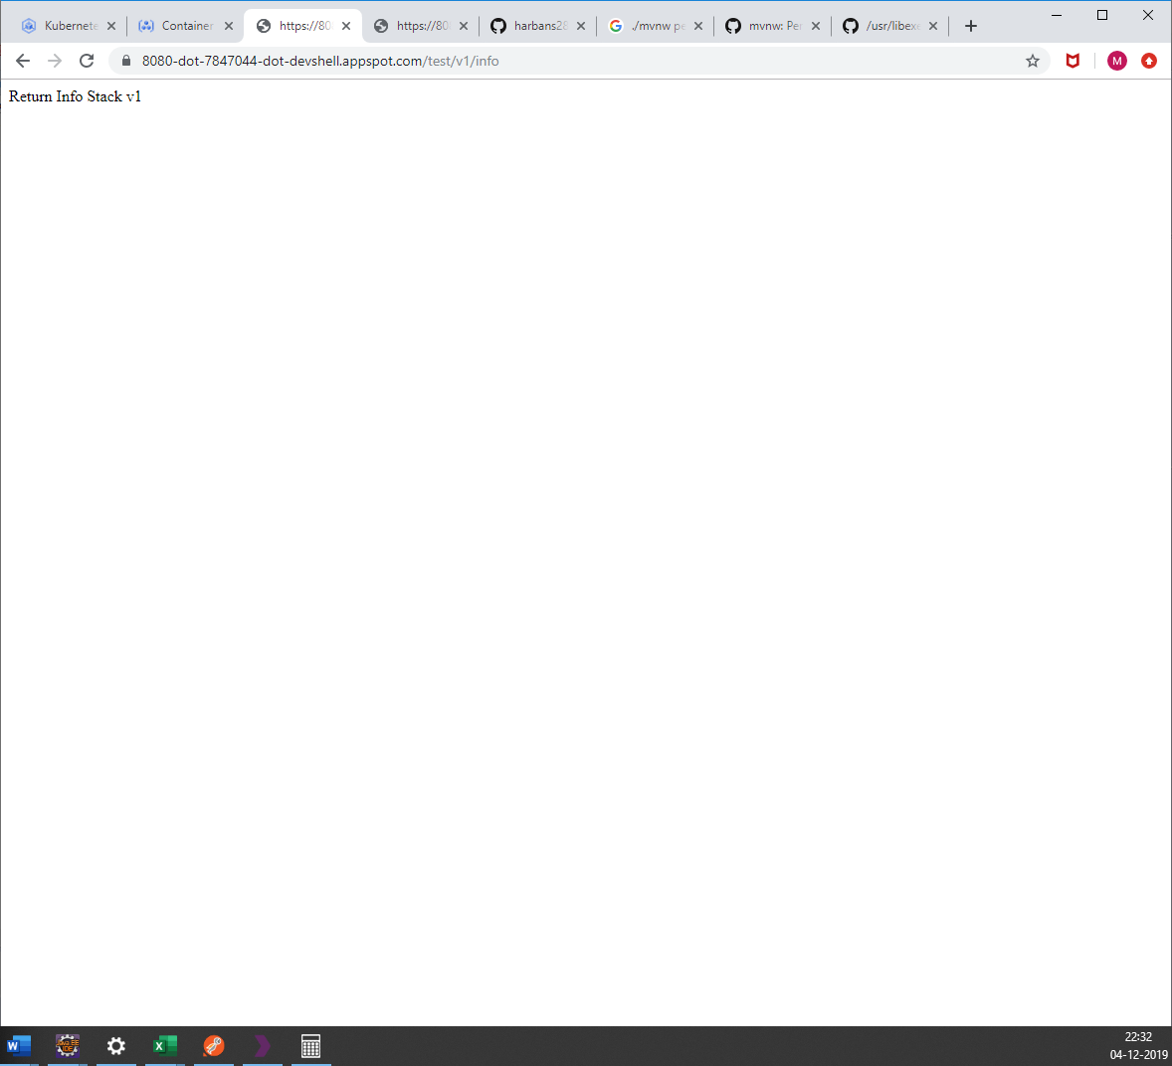

run a Deployment into the Kubernetes cluster

**kubectl run simplespringboot --image=gcr.io/$GOOGLE_CLOUD_PROJECT/simplespringboot:v1 --port=8080**

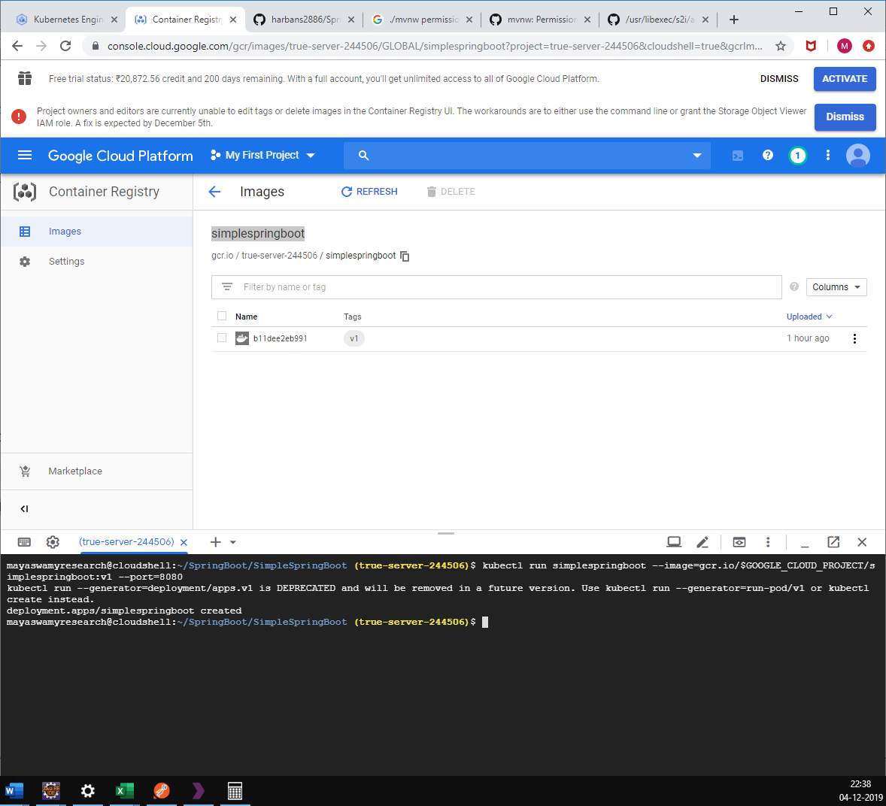

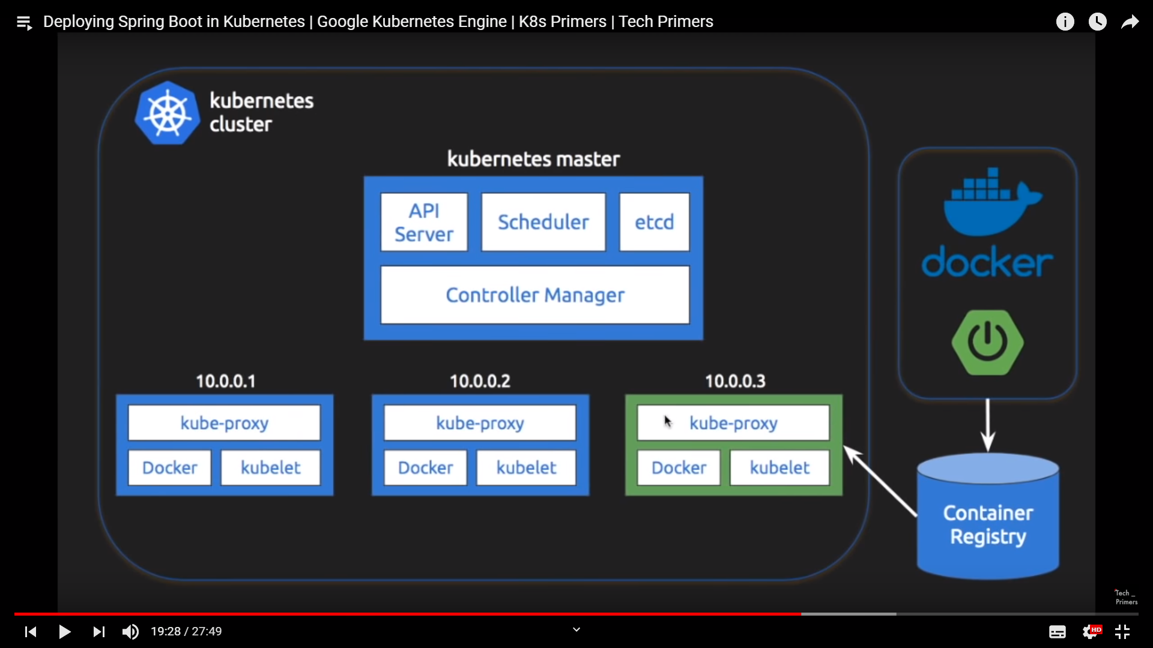

check the deployments

**kubectl get deployments**

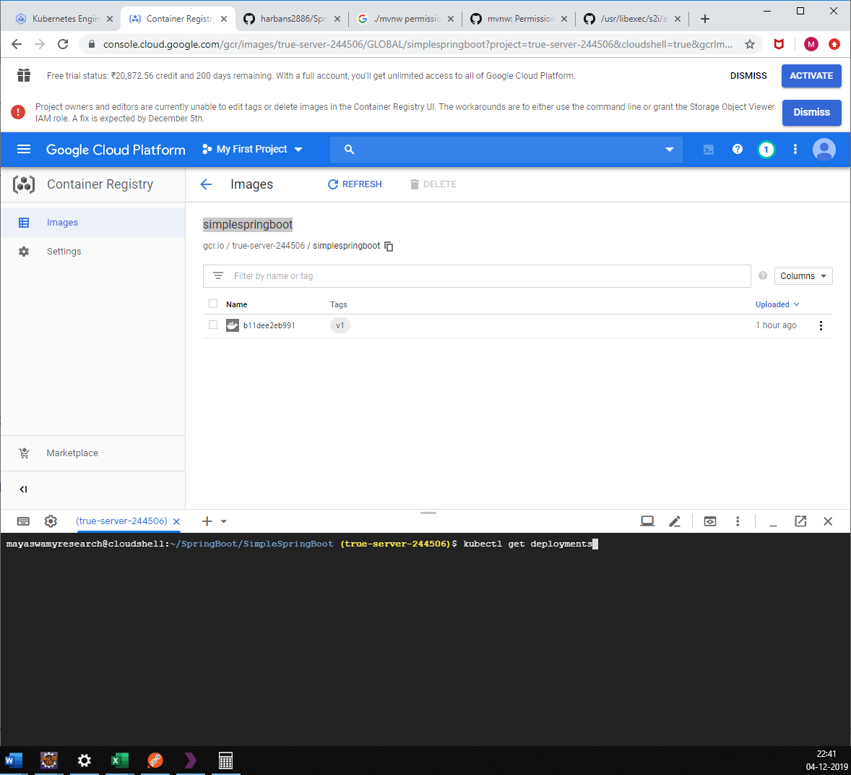

Check the PODS

**kubectl get pods**

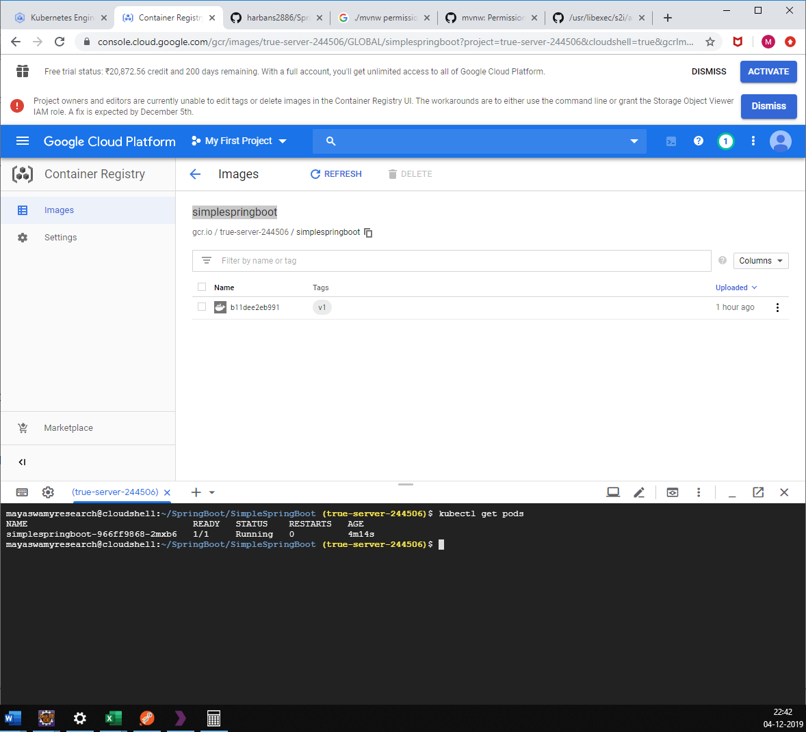

Check Service (no New Service)

**kubectl get services**

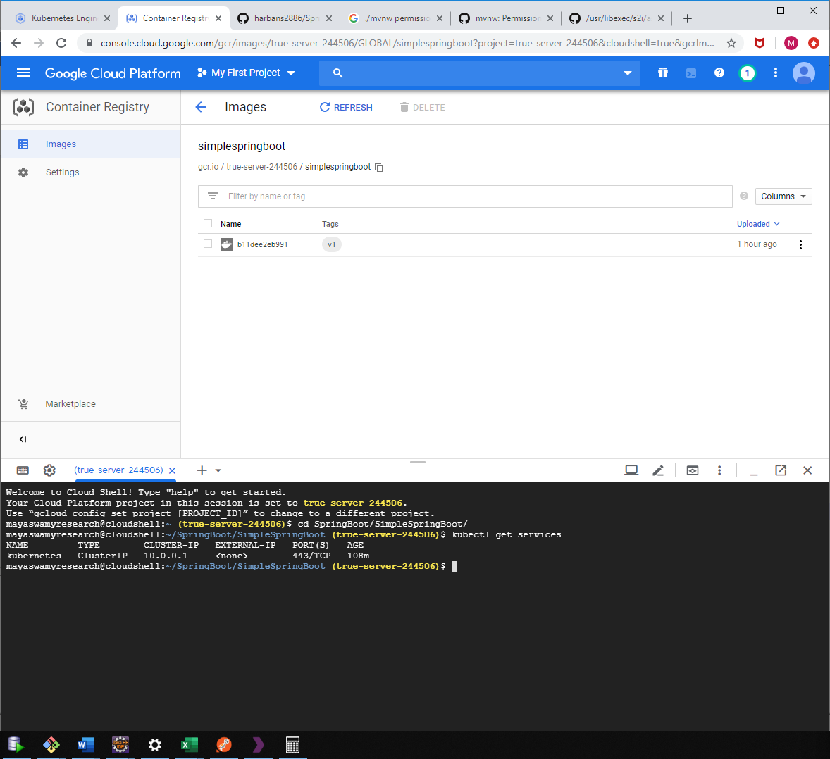

Create a new Service to connect to the Deployments(shown in figure)

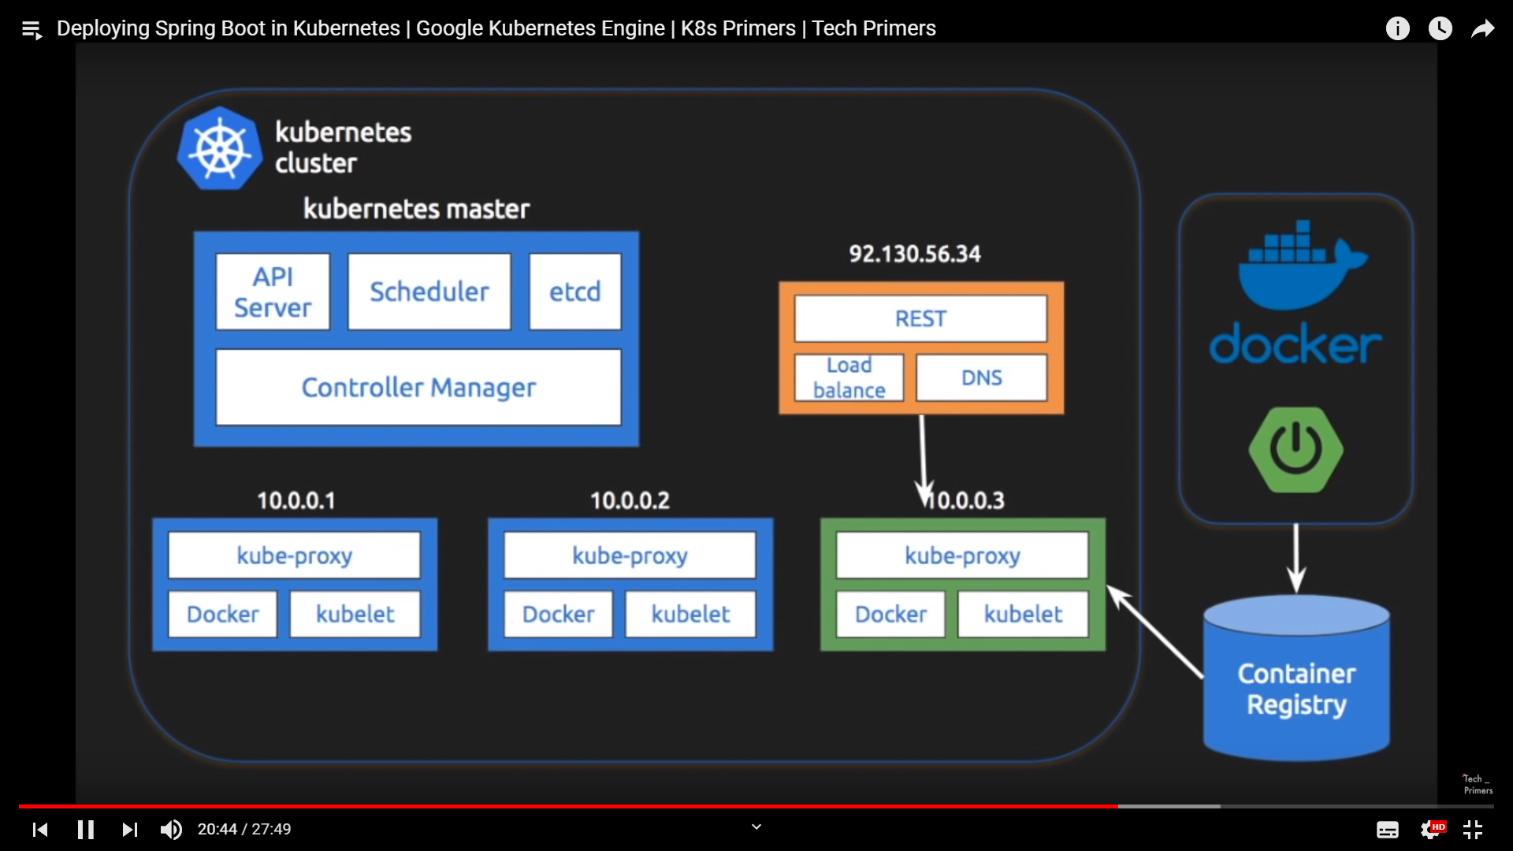

Expose Load Balancer using commands (can be done via .yml file which is a good practice)

**kubectl expose deployment simplespringboot --type=LoadBalancer**

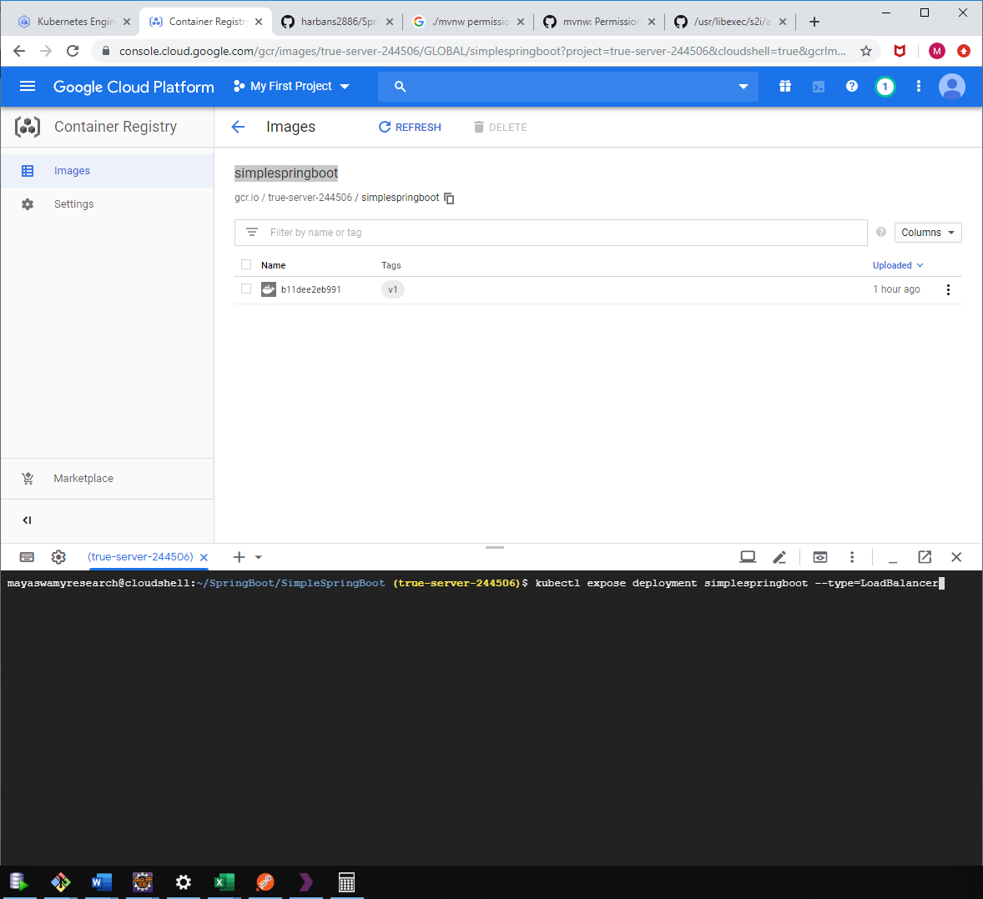

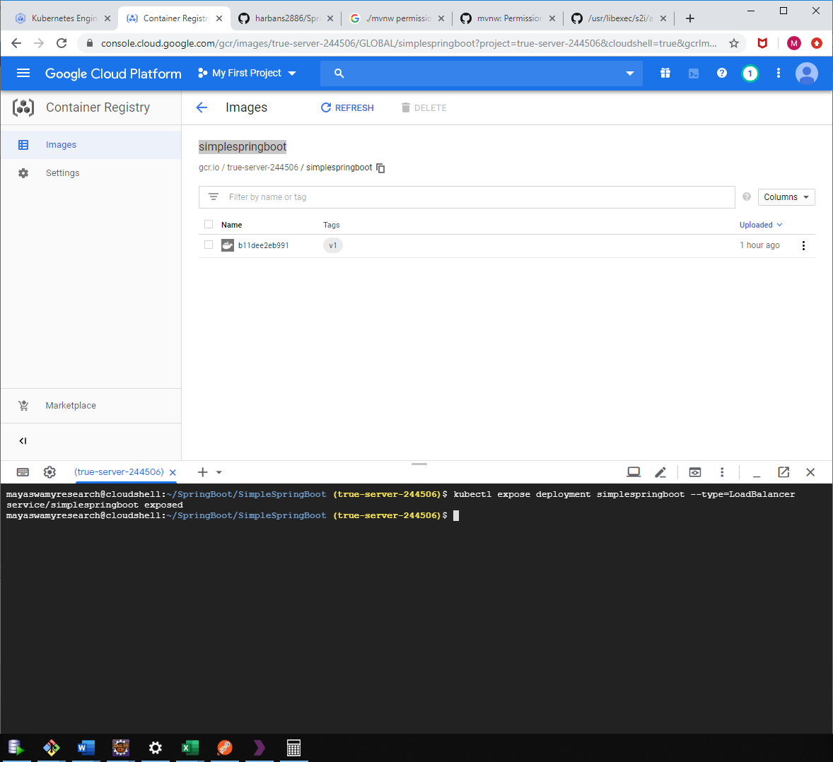

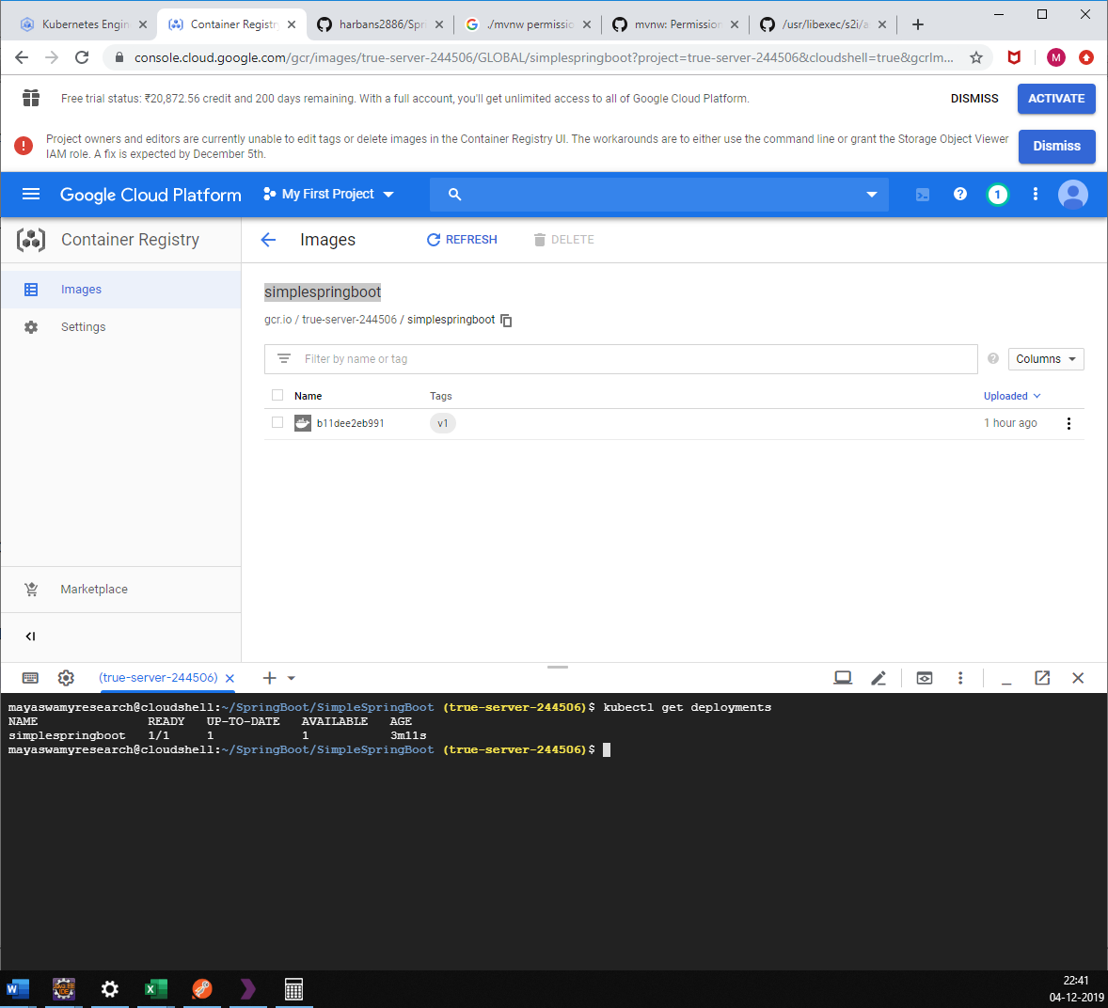

Check Service (New Service)

kubectl get services

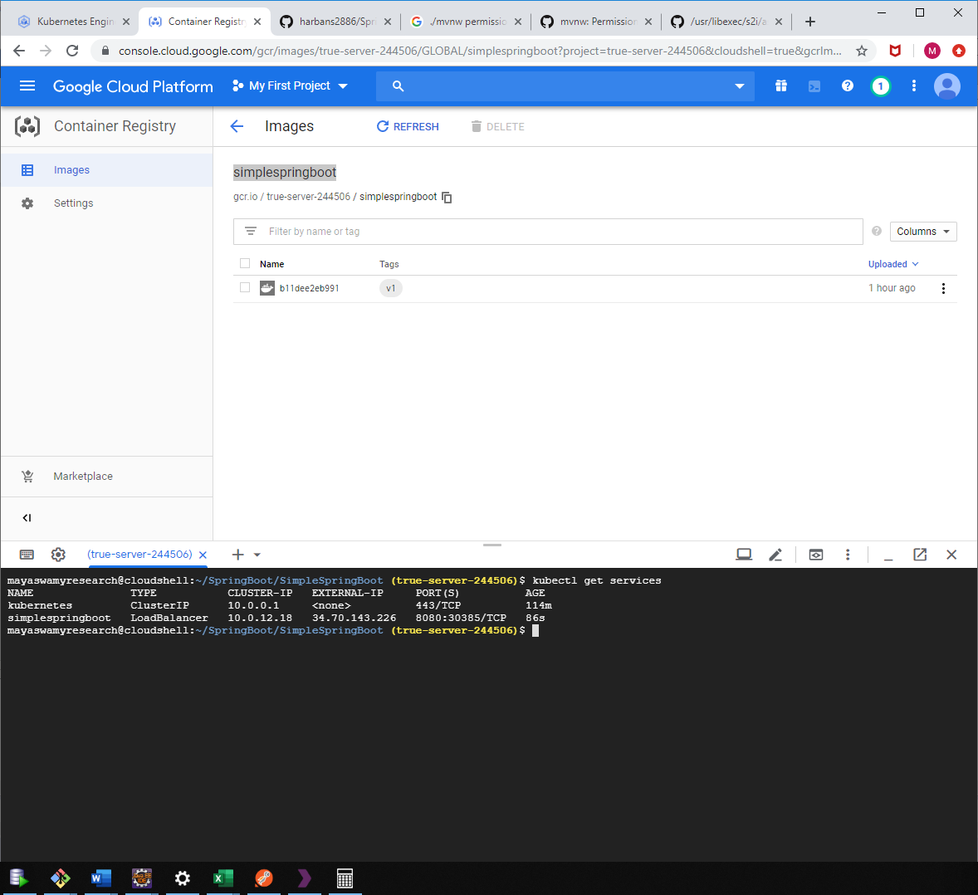

Using the external IP we can access our deployment

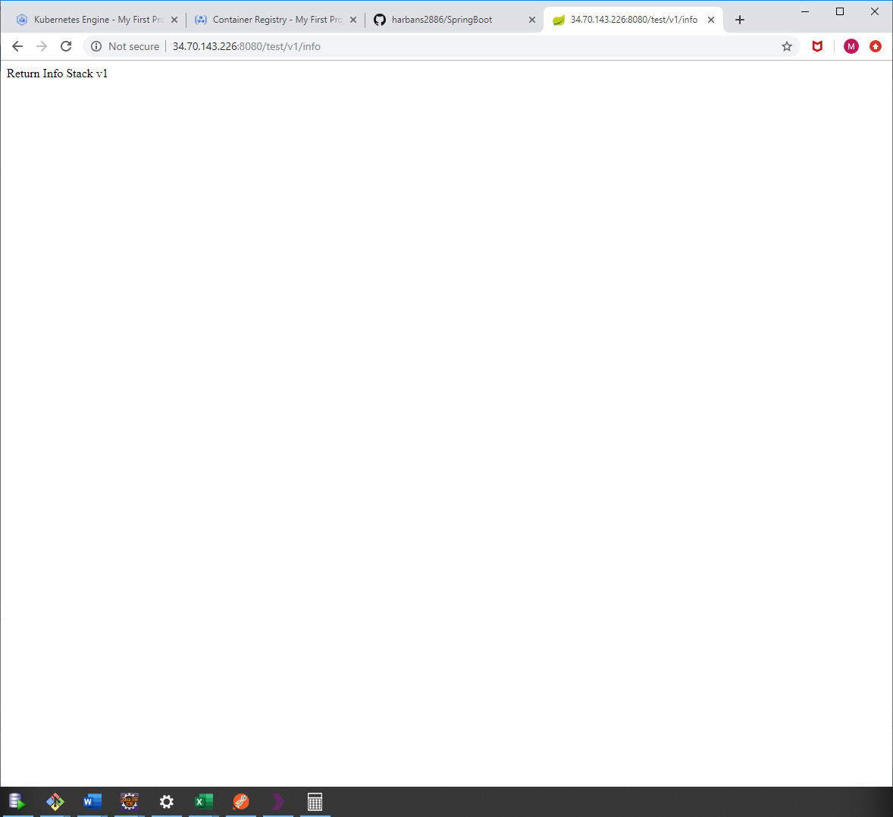

For now, only one deployment in one pod is running

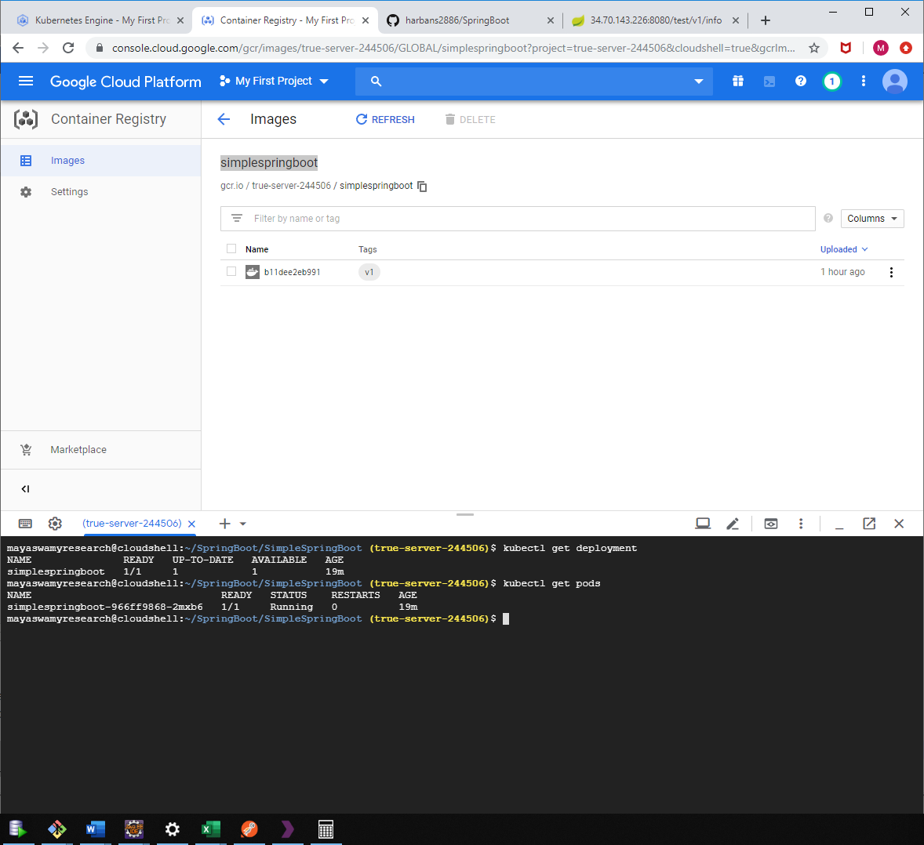

How to scale the deployment using commands(will do it using .yml file)

**kubectl scale deployment simplespringboot --replicas=3**

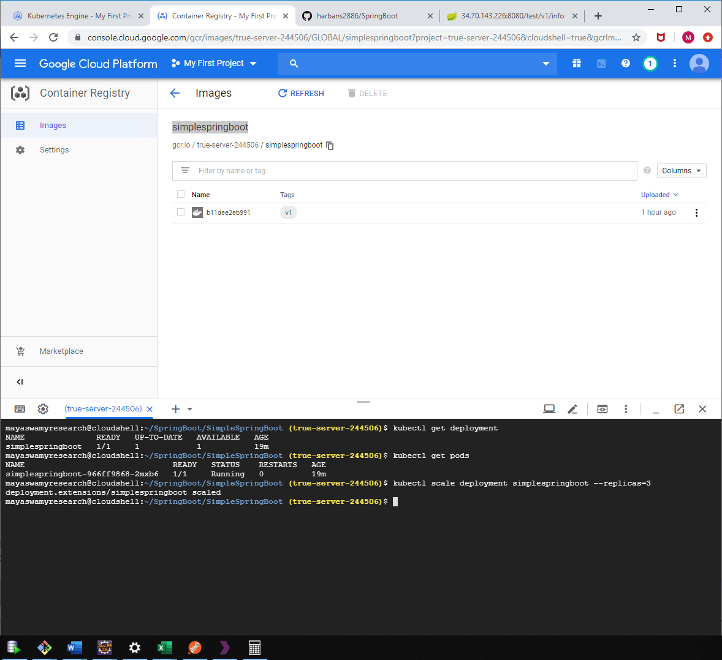

**kubectl get pods**

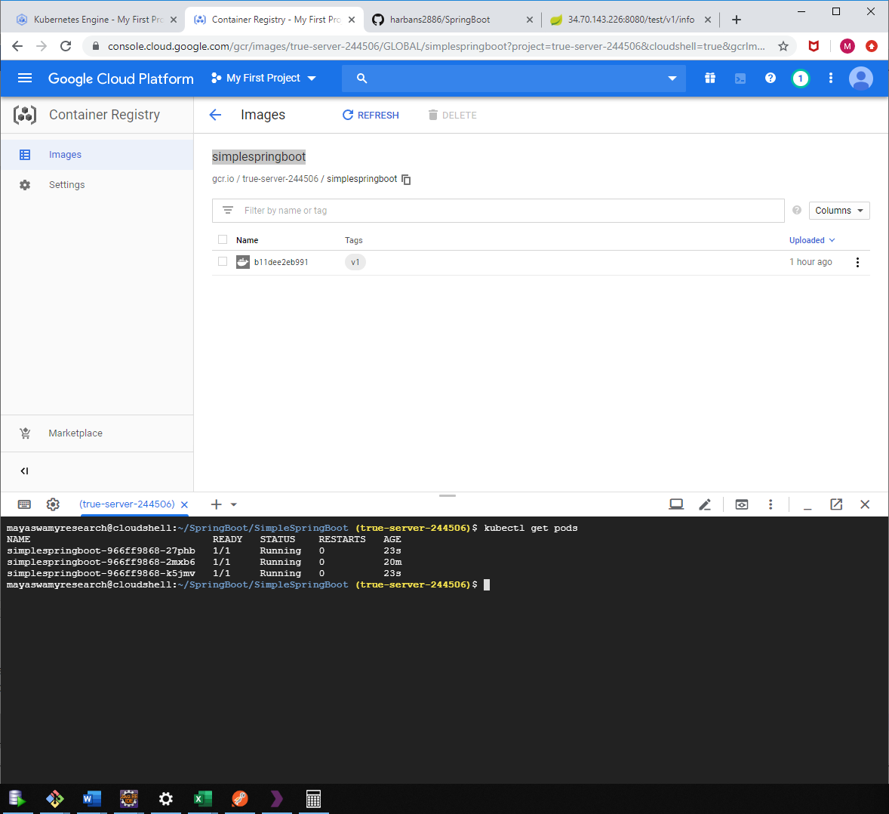

**kubectl get deployment**

